Sampling Theory ~(contimnue)

Example 1 : Consider a population with 5 units having value 1,5,7,9,13. Obtain all possible samples of size “2” drawn by:
1) Simple random sampling with replacement (srswr)
2) Simple random sampling without replacement (srswor)

1→ (1,1),(1,5),(1,7),(1,9),(1,13),(5,1),(5,5),…….,(7,1),(7,5),……,(13,13)
2→ (1,5),(1,7),(1,9),(1,13),(5,7),(5,9),(5,13),(7,9),(7,13),(9,13)

Example 2 : For a population with 5 units having value 1,5,7,9,13. Calculate population mean(µ) and varience (σ²). Consider all samples of size “2” drawn by srswr , calculate the different possible sample means() and prove that E(x’) = µ and V(x’) = σ²/n
→ here pop^{n} mean(µ) = (1+5+7+9+13)/5 = 7
pop^{n} variance(sigma²) = (1/n)Σ(x-µ)² = 16

the means of 25 possible samples drawn by srswr are(obtained by previous ans):
1,3,4,5,7,3,5,6,7,9,4,6,7,8,10,5,7,8,9,11,7,9,10,11,13
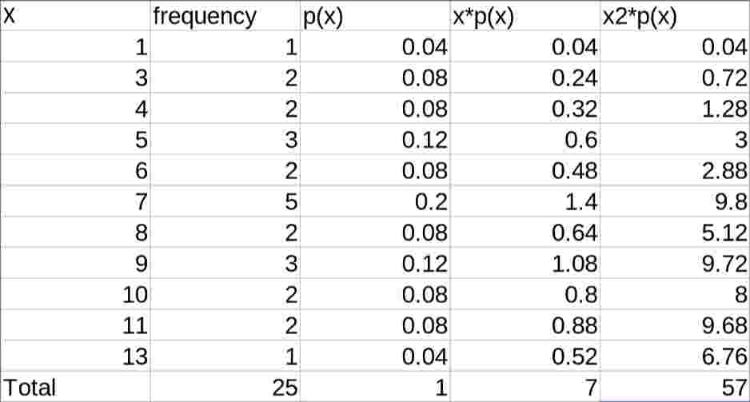

(all the “x” above diagram are x’)
Now,
E(X) = Σx’*p(x) = 7 = µ
v(X) = E(x’²) -(E(x’))²
= Σx’²*p(x’) - 7²
= 57-49
= 8 = 16/2 = σ² / n
therefore:
E(x’) = µ
V(x’) = σ² /n

So,
(x’-µ)/$\sqrt{σ2/n}$ ~ N(0,1)
(x’-µ=)/ σ² /n ~ N(0,1)

If σ² is pop^{n} varience then sample varience is
s² = (1/n) Σ(x-x’)²
It can be shown that:
E(s²) = (n-1)/n * σ²
E(s²) != σ²

However using
E(s²) = (n-1)/n * σ²
we get,

n/(n-1) E(s²) = σ²
= E(n/(n-1)s²) = σ²
= E(S²) = σ²
where,
S² = 1/(n-1)Σ (x - x’)²

